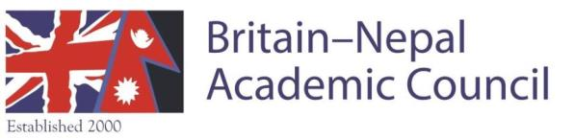
Registered Charity no. 1106987 (25/11/04)

Membership Application Form 2020

I would like to join / continue in the Britain-Nepal Academic Council* as:
a life member / an ordinary member / an associate member**
(please delete as applicable)

Name:

E-mail:

Contact number:

Institutional affiliation:

Address:

Research interests:

Signed:

Date:

Dues: Life Membership £250; Annual Ordinary Membership £30; Annual Associate Membership £15 **
OR
Discounted Standing Order Dues: Annual Ordinary Membership £24; Annual Associate Membership £12

Please send your application form to the Treasurer (Dr Fraser Sugden f.sugden@bham.ac.uk) who will contact you regarding payment options.

Membership of BNAC entitles you to the following: free attendance at annual Nepal Study Days; free attendance at BNAC annual lecture; regular mailings and updates on Nepal and Himalayan events in the UK; a vote at BNAC general meetings.

*The purpose of BNAC is “to advance the education of the public about Nepal and Nepalese life, including art, archaeology, anthropology, development, economy, health, history, literature, music, law, politics, and other such subjects as the trustees may from time to time determine” (BNAC Constitution, para 2).

**Individuals who wish to join BNAC as an ‘ordinary member’ should “hold established positions in, and/or are employed by the universities, research institutions, libraries and/or museums of Great Britain or Northern Ireland, as academics or researchers with an interest in Nepal” (ibid., para. 4a). Individuals who wish to join BNAC as an ‘associate member’ need to fulfil the following criterion: “Any individual who is an undergraduate, Master’s, or doctoral student in Great Britain or Northern Ireland, or who has a research interest in Nepal and has expressed their desire to become an Associate Member.” (ibid., para 5b).

To receive information regarding BNAC activities, please sign up on the BNAC Mailing List at: https://www.jiscmail.ac.uk/cgi-bin/webadmin?A0=BNAC

Website: www.bnac.ac.uk Facebook https://www.facebook.com/BNAC.UK Twitter : @BritainNepalAC

